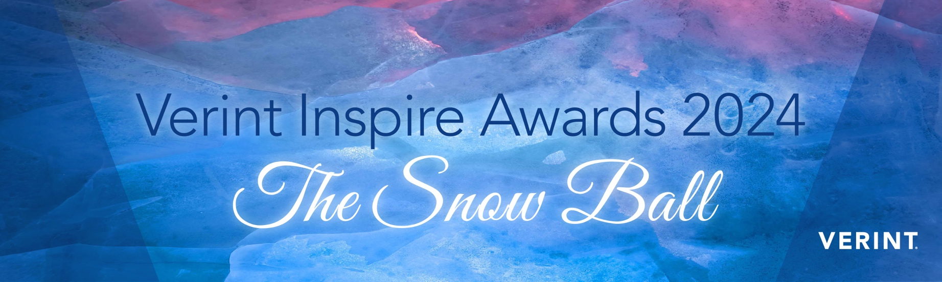

The Verint Inspire Awards 2024

This year, we are inviting you to enter the awards and share your successes.

It’s quick, easy with lots of benefits for you!

Entering is easy

Once you have reviewed your entry please submit it officially to [events.emea@verint.com](mailto:events.emea@verint.com)

Important!

Please do make sure you agree or disagree to Social Media & Press Release on the last page

– otherwise we cannot announce you if you are shortlisted or are a winner!

Tell us a little more about you

|  |  |
| --- | --- |
| Name: |  |
| Business email: |  |
| Company |  |
| Business phone |  |
| Team or person nominated for the awards (including job titles) |  |
| Award category (you can enter for more than one category): See full list of categories below Award nominee’s email | Please see the award categories page at the end of this document. You can enter more than one category. |

Here We Go – Your Entry for the   
Verint Inspire Awards 2024

**Did you know**? Our writers would love to help you write your entry – book a 20 minute call,   
they will draft your entry in all confidentiality and send it to you for review – all you then need   
to do is submit it. Just email [sabine.becker@verint.com](mailto:sabine.becker@verint.com) for the latest availability.

**Which Verint solution(s) are you using?** *(Insert details in the blue boxes)*

|  |
| --- |
|  |

**Overview & Challenges** – What were your key challenges and the reasons for choosing/using this solution to overcome them? How is your entity organised, ie provide some background, for example on the size of the operation in terms of customers you may help or the volume of interactions etc.

|  |
| --- |
|  |

**Objectives** – Detail the objectives, strategy and requirements to deliver on your particular project and/or challenges.

|  |
| --- |
|  |

**Innovation** – Outline any examples of innovative and forward thinking from individuals or teams throughout your particular project.

|  |
| --- |
|  |

**Results** – Provide clear metrics to demonstrate the results achieved. This could include improving customer satisfaction, increasing revenue, reducing operational costs, enhancing productivity and mitigating risk etc. across contact centre, back-office, branch, or marketing operations.

|  |
| --- |
|  |

The Award Categories

1. **Best Augmented Workforce**

For companies showcasing the best of an augmented workforce where bots or   
automation and humans work seamlessly to deliver excellent CX and customer journeys, whilst enhancing the agent experience. This can also include creative operational setups   
to overcome peaks in work, working with BPOs for example.

1. **Innovating with AI & Analytics**

Recognising the organisations who analyse, learn and innovate based on their customers’ experiences with the help of Verint Analytics and AI.

1. **Open CCaaS Trailblazer**

Recognising the innovative use of Open CCaaS in specific business cases – this could encompass any early adopters of Open CCaaS, as well as companies with a strong, clearly defined and connected CX strategy making use of multiple Verint bots or solutions.

1. **Supercharged Self-Service**

For organisations using innovative approaches to empower customers to self-serve – this could include use of solutions like Verint Community, customer-facing automation/bots, Knowledge Management, and more. If you’re using Verint solutions to deliver innovative self-service in any way, this is the category for you.

1. **Driving Digital First Engagement**

For creating customer journeys with a connected experience across your consumers’ digital and social channels of choice to create differentiated experiences at scale that drive customer loyalty.

1. **Excellence in Back Office**

For demonstrating significant improvements in Back Office operations which have led to efficiencies and enhancements that positively impact operational performance and the overall customer experience.

1. **Excellence in Regulatory Compliance**

To recognise the companies going far beyond “good enough” and cementing compliance and collaboration at the heart of their everyday actions and behaviours with a futureproof compliance strategy.

1. **Engaged Customer of the Year**

This award will be given to the most engaged customer who has demonstrated a strong implementation of Verint Solutions, engagement with Verint and other customers, and shares their story as an active Verint Elevate member.

We’d love to share your name and   
incredible story, if that’s ok with you?

**Everything will always be sent to you for approval beforehand!**

**Social Media YES/NO**

The nominee is happy to be included in short posts in the running up to the awards and congratulating shortlist entries, runners up and winners and announcing the awards ceremony.

**Case Study YES/NO**

All our best entries will be shortlisted to become case studies – we will send you a draft which you can review and change – you will receive 1 day of services for this in return for your time. Would you be interested?

**Press Release YES/NO**

If the nominee is selected as a winner, will the nominee’s organisation agree to participate in a joint press release, as well as recognition on Verint.com, announcing the nominee as an award recipient?

We are looking forward to celebrate your successes with you!

